**Membership Subscription Form**

INVERURIE MUSIC

PROMOTING CONCERTS

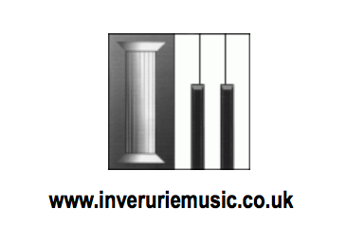

|  |  |  |
| --- | --- | --- |
| Name: |  | |
| Address:  (including postcode)  (tick if preferred means of contact) |  | |
| Email:  (tick if preferred means of contact) |  | |
| Telephone: |  | |
| Signature: |  | Date: |
| Please add the names of any additional subscribers and whether full, child or student | | |
|  | | |
|  | | |
|  | | |

Inverurie Music will retain your information and will contact you about concerts and musical activities/events. Please provide your consent to this by signing above and **choose your preferred method of contact (email/post)** by indicating this in the appropriate box.

Your details will be kept securely and will not be passed to anyone else. You can cancel these arrangements at any time by contacting [inveruriemusic@gmail.com](mailto:inveruriemusic@gmail.com)

#### **Subscription Cost for season 2020 - 2021** Quantity Total

**£20 for full price membership**

**£4 for** child/student membership      

***Optional donation to the Inverurie Music Award Scheme (see below)***

***Gift Aid your donation? Yes/No***

**Total paid**

#### Please indicate payment option – cheque/bank transfer)

#### **Cheques payable to ‘Inverurie Music’**

#### **Bank Details: Sort Code 80-08-41 Acc No. 00842458**

(please add your name and ‘IM sub’ as a reference for bank transfers)

#### **Send the completed form to Inverurie Music, c/o Benview Cottage, Chapel of Garioch, Inverurie AB51 5HE** or by email to inveruriemusic@gmail.com

#### **Inverurie Music Award Scheme**

This award scheme aims to benefit young musicians from Alford, Inverurie, Kemnay and Meldrum Academies to develop their musical skills and benefit from participation in musical activities. The young musicians can apply for financial support of up to £200 to help with their musical activities.

A range of musical activities and related expenses will be considered for funding.

The following list gives examples of what may be supported but does not cover all possibilities:

1. Music lessons or workshops.
2. Travel/accommodation related to music lessons, workshops or music competitions.
3. Books, printed music and materials for the study of music.
4. The purchase or repair of instruments and/or accessories for instruments.
5. Software to facilitate musical composition.
6. Equipment to record music.

Donations to the Inverurie Music Award Scheme fund are very welcome. More information can be found at inveruriemusic.org or on the Facebook page.

Please add Gift Aid to allow Inverurie Music to reclaim 25p for every £1 donated.

(Gift Aid declaration: I would like Inverurie Music to treat my donation as Gift Aid for reclaiming tax. I personally have paid or will pay an amount of Income Tax or Capital Gains Tax for the current tax year (6th April to 5th April) that is at least equal to the amount of tax claimed by all the charities (and any Community Amateur Sports Clubs – CASCs) that I donate to in the current year. I understand other taxes such as VAT and Council Tax do not qualify. I also understand that the charity will reclaim 25p of tax on every £1 that I have given.)

For more information go to [www.inveruriemusic.org](http://www.inveruriemusic.org) and search for award scheme