INVERURIE MUSIC
PROMOTING CONCERTS

Membership Subscription Form Season 2022-23
Name:
Address
including postcode:
(tick if preferred means of contact)
Email:
(tick if preferred means of contact)
Telephone:
Signature: |  | Date:
Please add the names of any additional subscribers
Your information will be kept securely and you will be contacted about concerts/musical activities and events. These arrangements can be cancelled at any time by contacting inveruriemusic@gmail.com

Subscription Cost for season (7 concerts) Quantity Total
£56 for full price membership

Free for under 25s in full-time education,
and those receiving disability or low-income benefits

Optional donation to the Inverurie Music Award Scheme
Gift Aid your donation? Yes/No (see attached note)
Total paid
Choose a payment option – preferably by bank transfer
(cheques payable to Inverurie Music or cash also welcome)
Bank Details: Sort Code 80-08-41 Account No. 00842458
(adding your name and ‘IM sub’ as a reference)
Send the form and payment if appropriate to Inverurie Music, c/o Benview Cottage, Chapel of Garioch, Inverurie AB51 5HE
Or, scan or take a photo of the form and send it to inveruriemusic@gmail.com
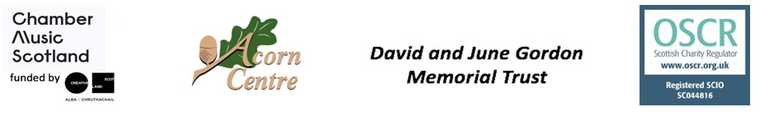

Inverurie Music Award Scheme

This award scheme aims to benefit young musicians from Alford, Inverurie, Kemnay and Meldrum Academies to develop their musical skills and benefit from participation in musical activities. The young musicians can apply for financial support to help with their musical activities.

A range of musical activities and related expenses will be considered for funding.
The following list gives examples of what may be supported but does not cover all possibilities:
- Music lessons or workshops.
- Travel/accommodation related to music lessons, workshops or music competitions.
- Books, printed music and materials for the study of music.
- The purchase or repair of instruments and/or accessories for instruments.
- Software to facilitate musical composition.
- Equipment to record music.

Donations to the Inverurie Music Award Scheme fund are very welcome. More information can be found at inveruriemusic.org or on the Facebook page.
Please add Gift Aid to allow Inverurie Music to reclaim 25p for every £1 donated.

(Gift Aid declaration: I would like Inverurie Music to treat my donation as Gift Aid for reclaiming tax. I personally have paid or will pay an amount of Income Tax or Capital Gains Tax for the current tax year (6th April to 5th April) that is at least equal to the amount of tax claimed by all the charities (and any Community Amateur Sports Clubs – CASCs) that I donate to in the current year. I understand other taxes such as VAT and Council Tax do not qualify. I also understand that the charity will reclaim 25p of tax on every £1 that I have given.)

